Wildfire detection and spread modelling using Deep Learning.

By Sharad Nataraj - Masters Student at San Jose State University| Data Scientist

## **Introduction**

Wildfires destroy thousands of acres of forest across the world. Last year the loss of vegetation was in excess of 9 million acres and destroyed more than 25000 structures in the United States alone. This is not taking into account the terrible pollution it causes to the environment.The key to controlling wildfires is early detection and then damage mitigation.

This article takes a 2 pronged approach to this. First, we will be exploring how to detect the wildfire early so that the ground support can take necessary action. Secondly we will be exploring how we can predict the spread of fire. We will be achieving this using deep learning techniques.

With the progress we have made in this century and particularly in the last two decades, we are able to have satellite images of regions of vegetation. We also have state of the art computing systems and algorithms particularly in the field of computer vision that can process this data and provide us with insights that can actually be used to solve real world problems.

Let us start with a high level overview of deep learning.

### **Deep learning**

To explain it in simple terms, deep learning is just learning from examples. We train models to filter,observe input inorder to use the information to predict, segregate, classify and cluster data. The motivation for deep learning is that it is built to work just like a human brain. Although that is a destination really far away, we are making progress at the rate of knots.

Imagining how our brain works just to help us see would make it very obvious that our brain can distinguish objects, colors, movement etc. Making a computer do the same is the field of computer vision. The term deep learning was associated with this technique because, in deep learning techniques like convoluted neural networks, artificial neural networks there are several layers of learning just like how our brain has layers of neurons consisting of axons and dendrites giving us the cognitive ability.

We can break down the functions of our brain generally into classification ( what is the object), segmentation ( distinguishing the object from the surrounding), clustering(associating various types of objects together).

We can perform all of this using neural networks too! In this article we are specifically looking at segmentation and prediction.

## How do we detect a wildfire using satellite imagery?

Using satellite imagery, we can get an aerial view of the land below. Our goal is to identify vegetation separately from a fire.

We have various sources of data for this. We have satellites like Resurs-P, we have the planet database that provides us with the image data for specific locations, we have data from other agencies like Nasa(<https://firms.modaps.eosdis.nasa.gov/map/#d:24hrs;@0.0,0.0,3z>) and data from private organizations(<http://cfdb.univ-corse.fr/index.php?menu=1>). However, these images may vary in size, color contrast, color schemes and noise levels. We need to make sure that we have a consistent standard of the data that we use. We need to prepare and process the data before we can use it to train or query the model.

### Data Preparation

First of all we need to make sure that we have the lowest noise possible. The image can have noise due to radiation, clouds, or glare reflecting from different surfaces. We can align low level images and overlap them to reduce such noise. Further all aerial photos need to be normalized so each pixel only contains values in the range of [0,255].

Next, the numerous fragments of data are stitched together. The images are overlapped near the edges. This makes the artifacts less significant near the boundaries and reduces false positives. Then , a binary mask is applied which converts the pictures into monochrome to increase contrast. The image and associated binary mask is sampled to create a 256*256 images. The technique of data windowing is used with a step of 128 pixels. Data windowing is the technique that can be used to sample image data by slicing the images into more manageable pieces.

The following images show the images and binary masks for two images. [ Obtained from research paper [Wildfire Segmentation on Satellite Images using](https://ieeexplore-ieee-org.libaccess.sjlibrary.org/stamp/stamp.jsp?tp=&arnumber=9067475)

[Deep Learning by Vladimir Khryashchev and Roman Larionov from the 2020 MWENT](https://ieeexplore-ieee-org.libaccess.sjlibrary.org/stamp/stamp.jsp?tp=&arnumber=9067475)]

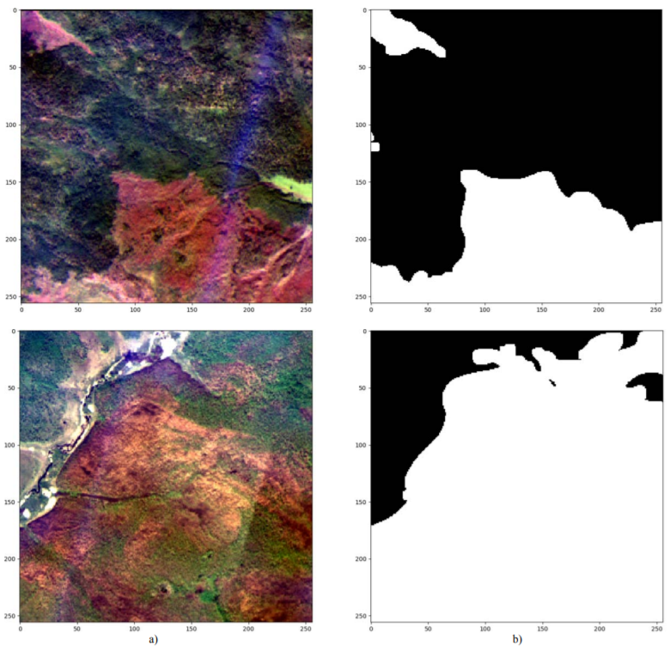

After applying the binary mask the vegetation shows up as dark black. We can use this contrast to use actual images of wildfires to train or model.

Traditionally, neural networks need a lot of data to train on. We need to feed data with labels to train the model. In our case as we are dealing with geospatial images, we can apply transformations to augment the data. Some of the transformations are :

* Rotations [90°, 180°,270°]
* Mirroring[along x and y axes]
* Image shifts by scaling

This will increase the training set to 8 times the original size!

## Training the Model

As mentioned earlier we are using a Convolutional neural network to train the model. The researchers have deployed this on the Nvidia DGX-1 supercomputer as handling image data could be computationally heavy.

A popular neural network called U-Net is used. This neural network has gained immense popularity for image segmentation tasks. It was originally used for biomedical image segmentation. It has performed with exceptional results.

The neural network has 3 phases, compression(encoding), bottle neck and then the expansion ( decoding). Further there are data channels between these phases. It uses a combination of convolutions and Max Pooling to train the model. The architecture of this neural network is shaped like a ‘U’. Hence the name U-Net.

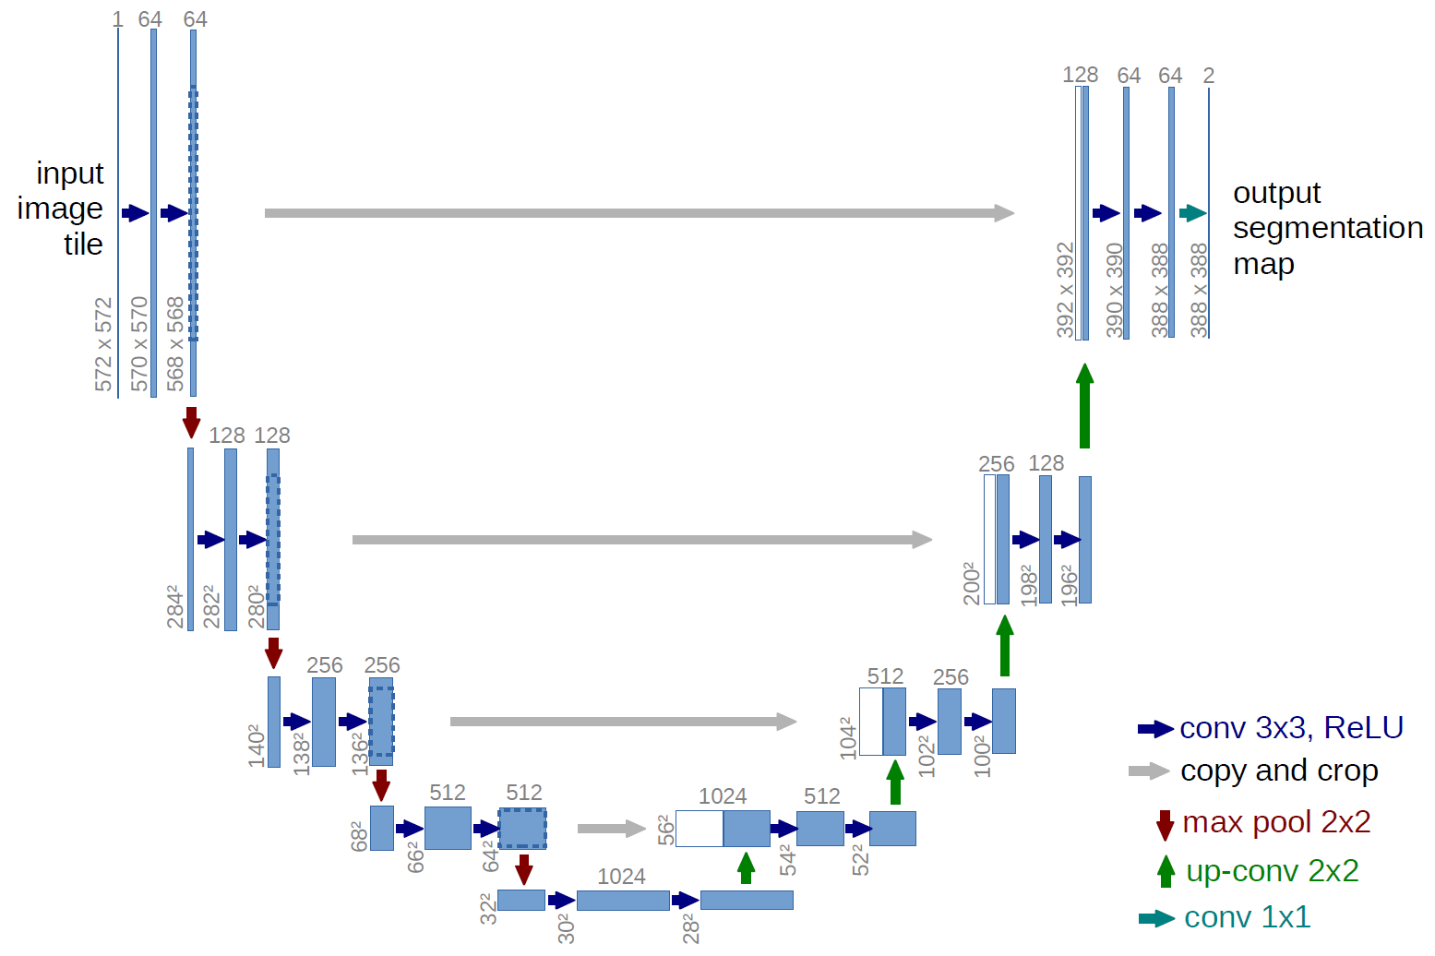

It starts by applying convolutions and max pooling components to encode and then the reverse along with the encoding samples to decode the image. This produces an output segmentation map. During encoding, the dimension of the data is reduced and the other way round for decoding.

For an in depth understanding of the U-net refer to this youtube video. <https://www.youtube.com/watch?v=azM57JuQpQI>

## U-Net results

The metrics can be calculated using F1 score. During training, if the IoU for a pixel is higher than 0.5 then it is an area of interest.

The true image, the actual mask and then the predicted mask is shown below for sample data.

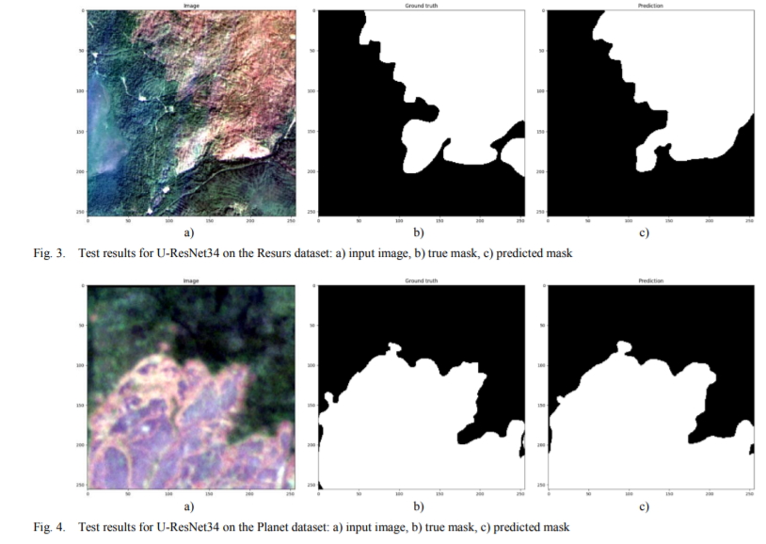

The model has satisfactorily predicted the wildfire(areas in white).

Let us move on to the next phase of wildfire spread modelling. This is important for damage mitigation while the fire is brought under control. Further by accurately predicting the spread of the fire, we can take precautionary measures to control the fire.

# 

# Wildfire spread modelling

The data is once again obtained from satellite images. However, in this case we also need geographical data like slope, wind, the type of vegetation to build an accurate model. To make the model more accurate, we will be normalizing the RGB data from the satellite using the formula below.



Where α,ꞵ,γ are mixing coefficients with values between 0 and 1. IRGB  is the matrix component of RGB , IHSI is the matrix component of (hue, saturation, intensity) and If is the frequency spectrum.

## Building the model

The model is based on [Rothermel’s model](https://www.fs.usda.gov/treesearch/pubs/55928). It takes into account the wind, vegetation density and the heat conduction.

### Heat Conduction Model

Using the concepts of conservation of energy we can say that each area of vegetation is in 3 states, on fire, no fire and burnt out. We can state few rules such as :

* If a piece of vegetation is burning (on fire) the next state should be burnt out.
* A currently burning cell will burn until time t.
* A cell which is not on fire but one of its surrounding cells is on fire, then at time t the cell will be on fire.

But as we are predicting the spread, rule #3 can be stated as if the cell is not on fire and its surrounding cells are on fire then the current cell will be on fire with a probability of Pf.

### Topographical model

The topography of a cell will affect how the fire spreads. This is proven by empirical analysis. A flat terrain or an upward slope will spread the flame faster. A jagged terrain will slow down the spread.

The probability can be defined as,

Ps=P0s+P1scos(tθs),

Where Ps represent the fire propagation probability affected by the train slope, P0s is the baseline propagation probability (when the slope is zero), P1s is the slope-dependent propagation probability, θs is the slope angle of the patch, and t is an adjustable coefficient that depends on the experiments.

### Compensation for wind

Wind affects where the heat is transferred. A fire can be blown in the direction of the wind. To model that we can formulate as follows.

Pw=P0w+P1wcos(awθw),

where P0w is the baseline propagation probability in no-wind condition, P1w is the wind-dependent propagation probability, θw is the direction between the wind and the line connecting the cell to its adjacent cell, and aw is a tuning parameter. The parameters P0w, P1w, and aw are obtained from experiments.

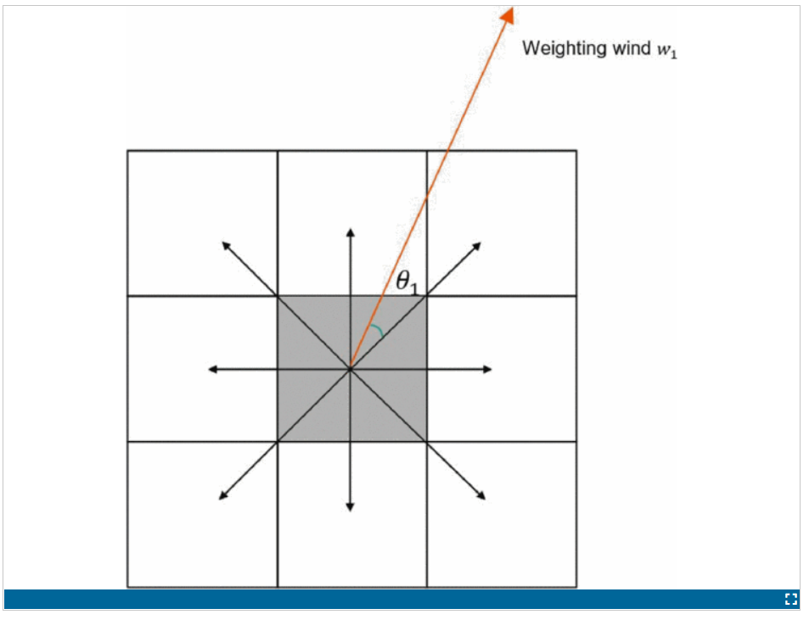

### The influence of vegetation density

We need to calculate the region with maximum vegetation connectivity and concentration from the existing fire. This important factor was not considered until it was published in the [research paper](https://ieeexplore-ieee-org.libaccess.sjlibrary.org/xpl/conhome/9210704/proceeding).

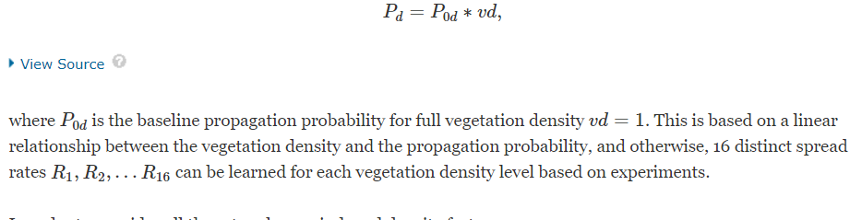

All together we can build the mathematical model as,



The above equation will five us the probability of a fire spreading to the surrounding area based on the geographical, meteorological and topographical features. We can predict the path based on a probability threshold.

# Conclusion

Using advanced machine learning, mathematical and image processing techniques, we can predict the existence, the path of a wildfire. The importance of this is enormous as it can lead to early detection and mitigation of the wildfire preventing harm to the society, wildlife and the environment.

The prediction of the path can be improved further by implementing a machine learning model to calculate the actual probability threshold to provide accurate prediction.

References :

* [Wildfire Segmentation on Satellite Images using Deep Learning](https://ieeexplore-ieee-org.libaccess.sjlibrary.org/stamp/stamp.jsp?tp=&arnumber=9067475)
* [Wildfire Spread Modeling with Aerial Image Processing](https://ieeexplore-ieee-org.libaccess.sjlibrary.org/document/9217742/figures#figures)
* [DigitalSreeni on youtube](https://www.youtube.com/watch?v=azM57JuQpQI)
* [U-Net: Convolutional Networks for Biomedical Image Segmentation](https://link.springer.com/content/pdf/10.1007/978-3-319-24574-4_28.pdf)
* [Learning from Time-Changing Data with Adaptive Windowing](https://citeseerx.ist.psu.edu/viewdoc/download?doi=10.1.1.144.2279&rep=rep1&type=pdf)
* [Problem of artifacts](https://pubmed.ncbi.nlm.nih.gov/17056954/)
* [Advanced Computer Vision](https://www.sciencedirect.com/science/article/pii/S0379711217302114#tbl1)